JAVASCRIPT BEST PRACTICE AND CONCEPTUAL QUESTIONS AND SOLUTION CODES

1. *Map Transformation:*

- Q: Given an array of integers, use the map method to square each element and return a new array with the squared values.

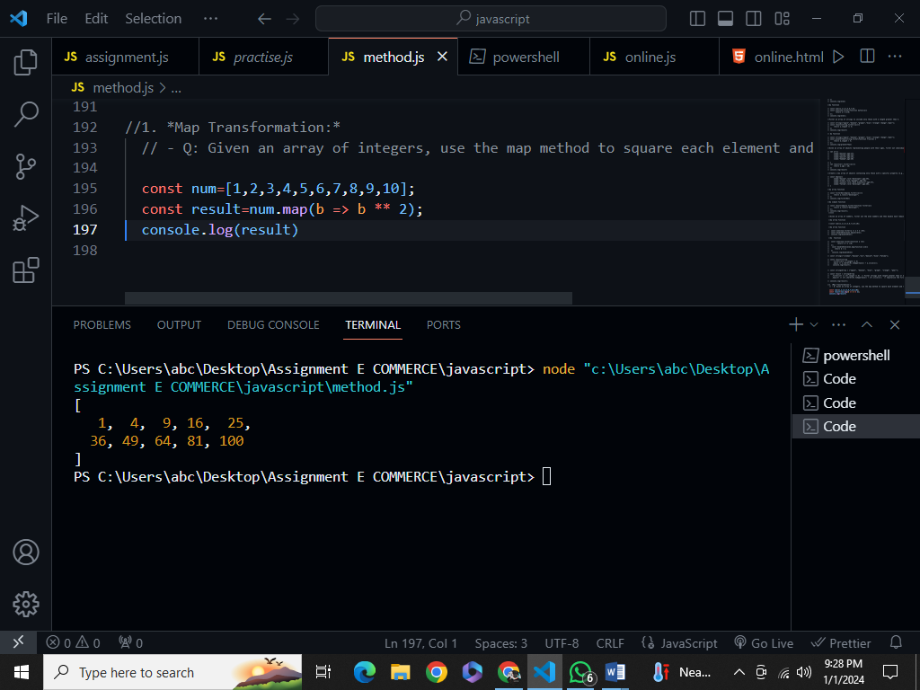

2. *Filter and Map Combination:*

- Q: Take an array of strings, filter out the ones with a length less than 5, and then capitalize the remaining strings using the map method.

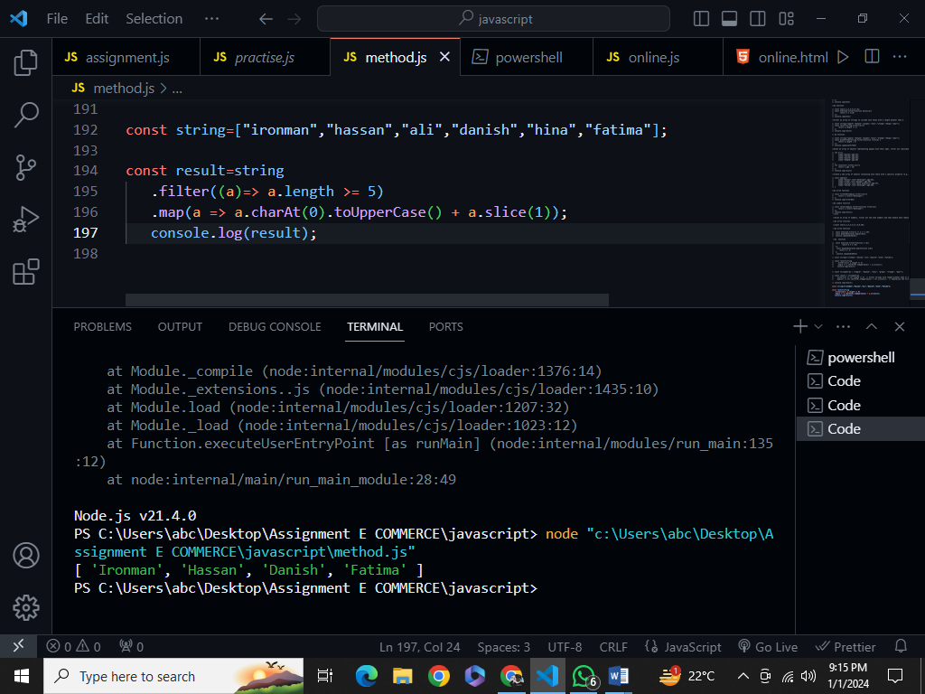

3. *Sorting Objects:*

- Q: Given an array of objects with a 'price' property, use the sort method to arrange them in descending order based on their prices.

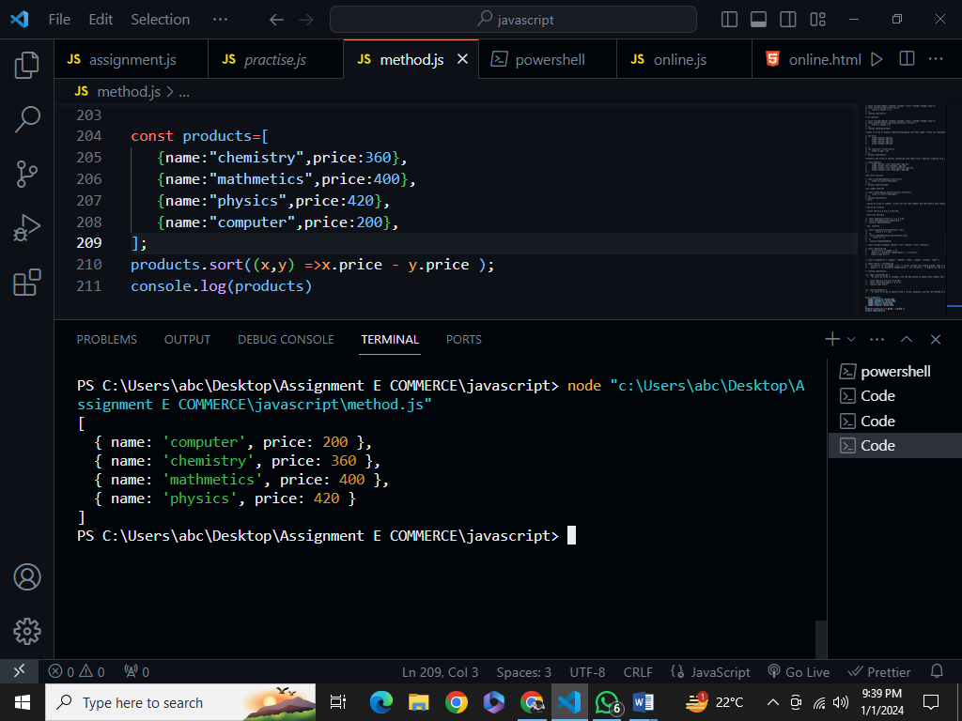

4. *Reduce for Aggregation:*  
   - Q: Use the reduce method to find the total sum of all even numbers in an array of integers.

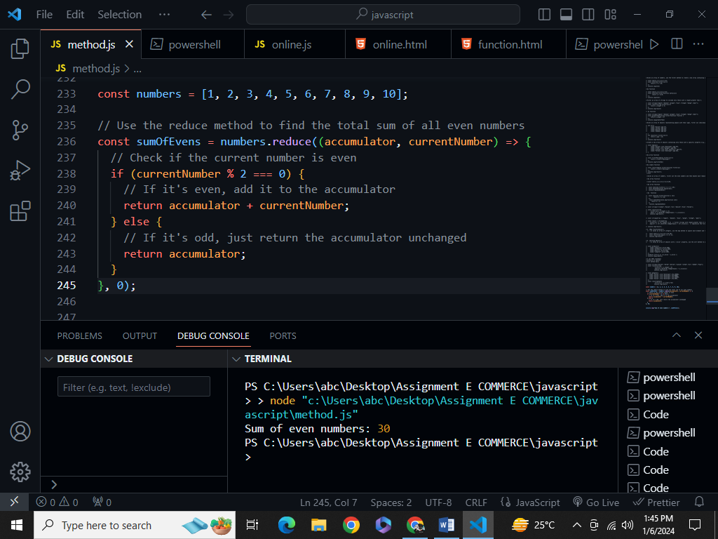

5. *Find and Modify:*  
   - Q: Given an array of objects with 'id' properties, use the find method to locate an object with a specific 'id' and update its 'status' property to 'completed'.

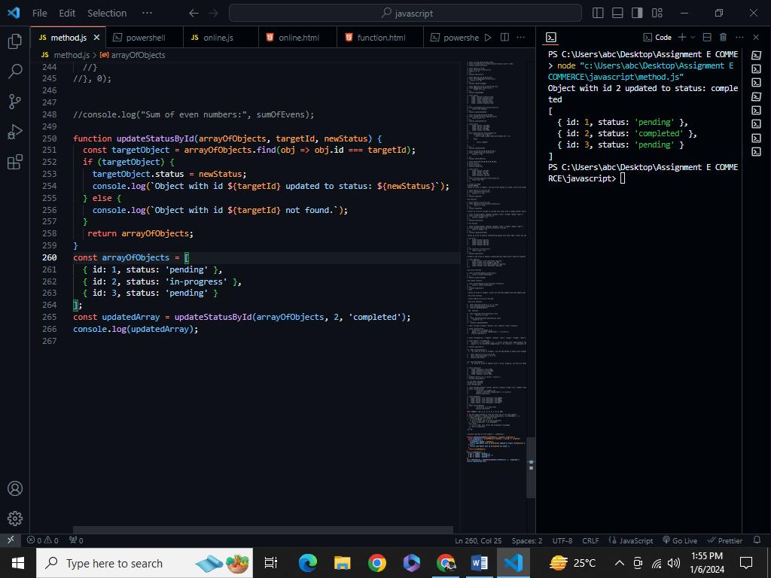

6. *Chaining Methods:*  
   - Q: Create a chain of array methods to find the average of all positive numbers in an array of mixed integers and return the result rounded to two decimal places.

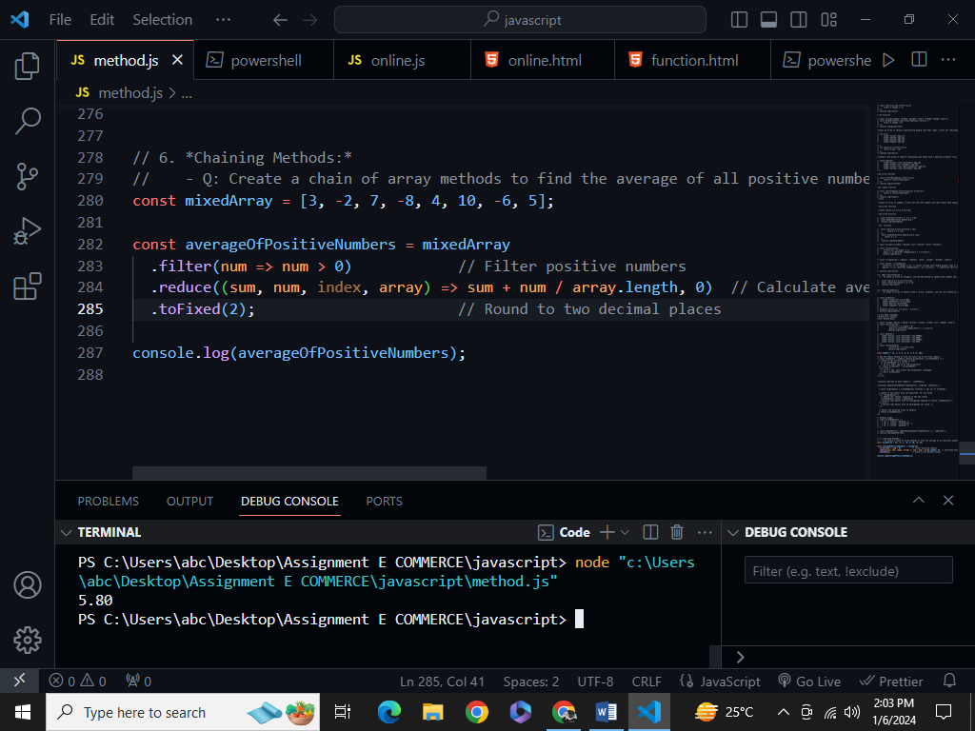

7. *Conditional Filtering:*  
   - Q: Implement a function that takes an array of objects with 'age' properties and returns an array of those who are adults (age 18 and above) using the filter method.

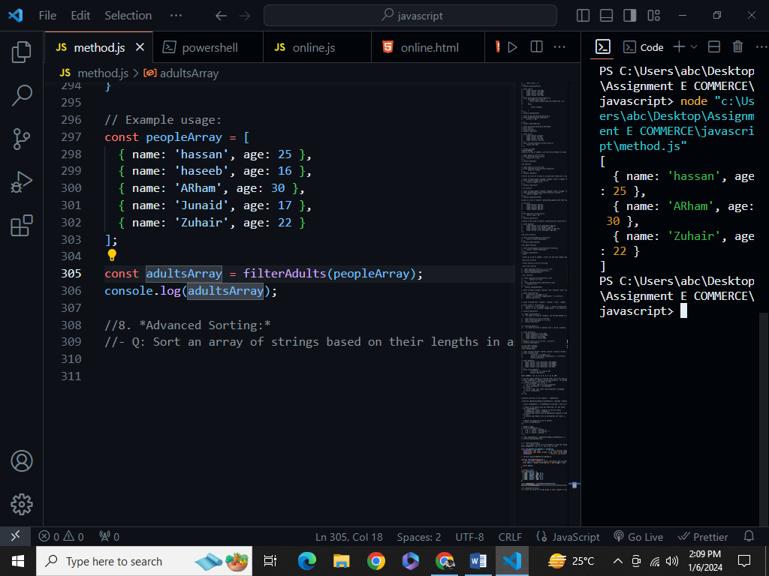

8. *Advanced Sorting:*  
   - Q: Sort an array of strings based on their lengths in ascending order. If two strings have the same length, maintain their relative order in the sorted array.

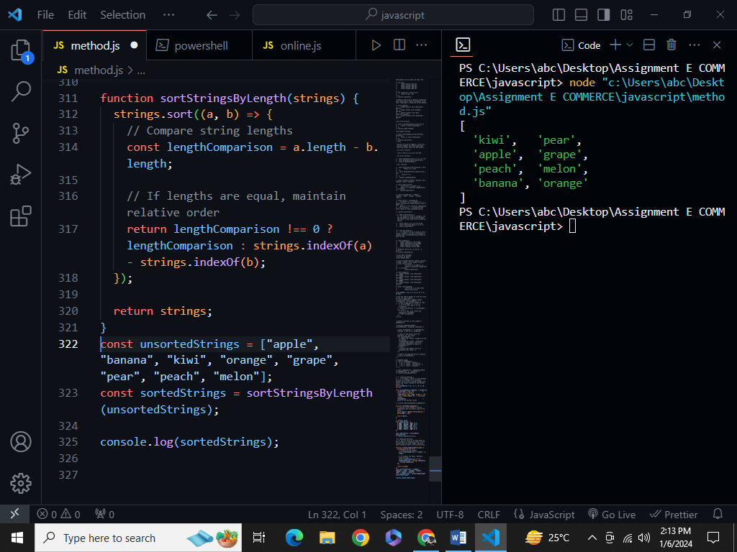

9. *Nested Array Operations:*  
   - Q: Given an array of arrays containing numbers, use a combination of array methods to flatten the structure and then calculate the sum of all the numbers

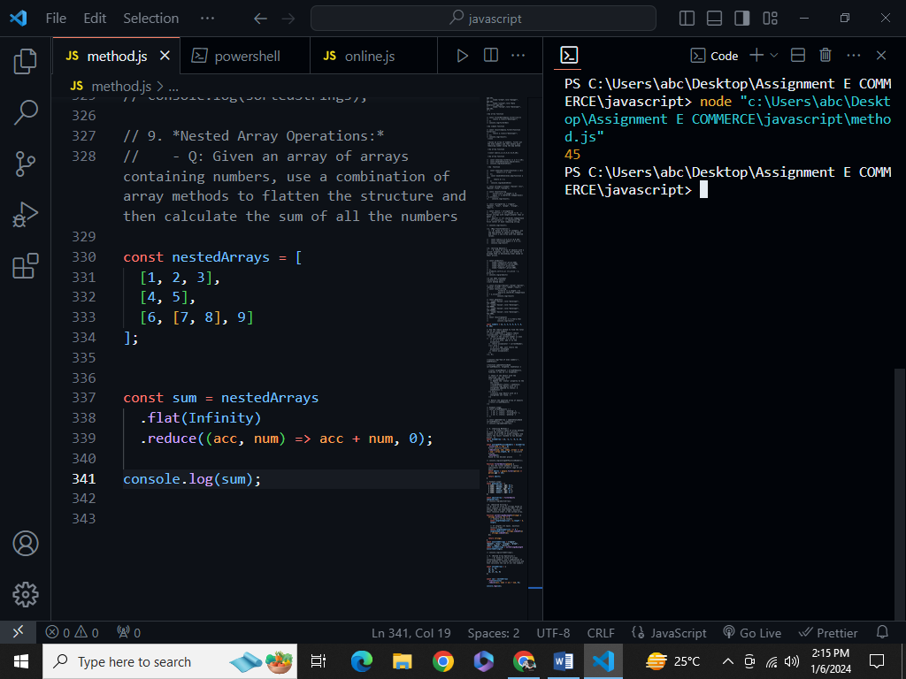

10. *Error Handling with Find:*  
    - Q: Modify the find method to handle the scenario where the desired element is not found, returning a custom default object instead.

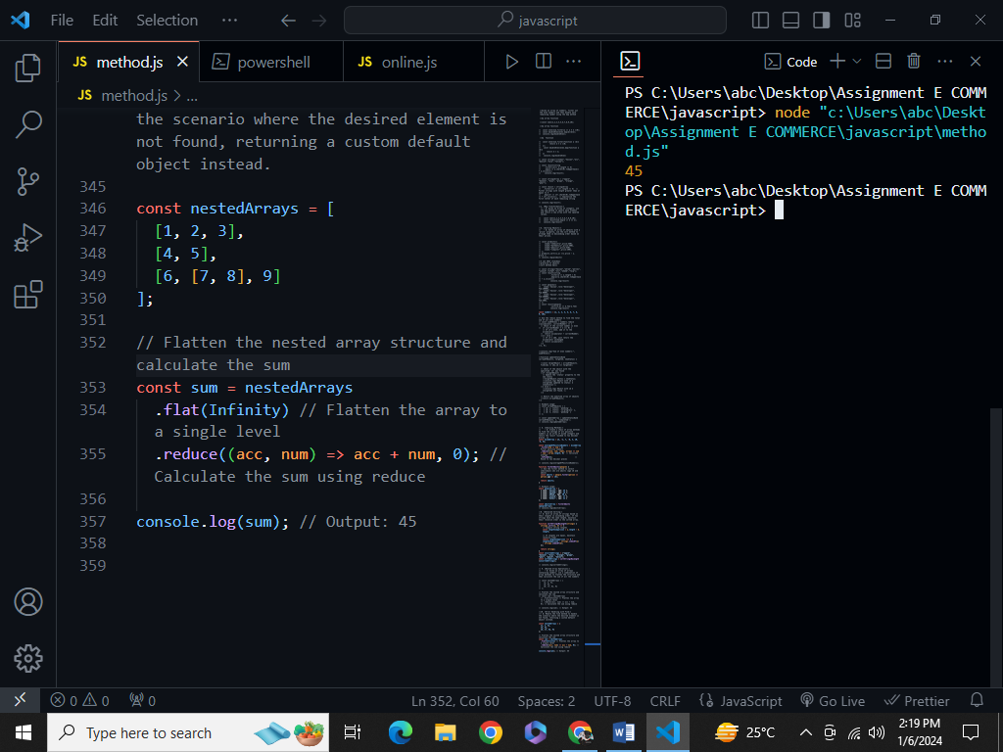

11. *Map Method:*  
   - Q: How does the map method work in JavaScript, and can you provide an example of when you might use it to manipulate an array of objects?

**The map method in JavaScript is used to create a new array by applying a given function to each element of an existing array. It doesn't modify the original array; instead, it returns a new array with the results of applying the provided function to each element.**

**Here's how the map method works:**

*const newArray = originalArray.map((currentValue, index, array) => {*

*// Your transformation logic here*

*return transformedValue;*

*});*

* **currentValue**: The current element being processed in the array.
* **index**: The index of the current element being processed.
* **array**: The array on which **map** was called.

Here's an example of using the **map** method to manipulate an array of objects:

*const students = [*

*{ id: 1, name: 'Alice', grade: 90 },*

*{ id: 2, name: 'Bob', grade: 85 },*

*{ id: 3, name: 'Charlie', grade: 95 }*

*];*

*// Example: Create a new array with student names and their grades*

*const studentInfo = students.map(student => {*

*return {*

*name: student.name,*

*grade: student.grade*

*};*

*});*

*console.log(studentInfo);*

In this example:

* The **map** method is used to create a new array **studentInfo**.
* The provided function takes each **student** object from the original array and returns a new object with only the **name** and **grade** properties.
* The resulting **studentInfo** array contains objects with names and grades, extracted from the original array of student objects.

**12. *Filter Method:*  
   - Q: Explain the purpose of the filter method. Provide an example where you use filter to extract elements from an array based on a specific condition.**

The **filter** method in JavaScript is used to create a new array containing elements that satisfy a specific condition. It provides a concise way to extract elements from an existing array based on a specified criteria or condition.

Here's how the **filter** method works:

*const newArray = originalArray.filter((currentValue, index, array) => {*

*// Your filtering condition here*

*return isConditionSatisfied;*

*});*

* **currentValue**: The current element being processed in the array.
* **index**: The index of the current element being processed.
* **array**: The array on which **filter** was called.

Here's a simple example of using the **filter** method to extract even numbers from an array:

*const numbers = [1, 2, 3, 4, 5, 6, 7, 8, 9, 10];*

*// Example: Filter out even numbers*

*const evenNumbers = numbers.filter(num => num % 2 === 0);*

*console.log(evenNumbers);*

**In this example:**

* The **filter** method is used to create a new array **evenNumbers**.
* The provided function checks if each **num** is an even number (**num % 2 === 0**).
* The resulting **evenNumbers** array contains only the elements that satisfy the condition (even numbers).

**13. *Sort Method:*  
   - Q: Discuss the default behavior of the sort method for strings and numbers. How would you use a custom comparison function to sort an array of objects by a specific property?**

**Sort Method for Strings and Numbers:**

The `sort` method in JavaScript is used to arrange the elements of an array in place. By default, it sorts elements as strings and converts elements into strings for comparison.

- **For Strings:**

- Strings are sorted based on their UTF-16 code units. This means that uppercase letters come before lowercase letters, and the sorting is lexicographic (dictionary) order.

- **For Numbers:**

- Numbers are also sorted as strings by default. This can lead to unexpected results because the sorting is based on the string representation of numbers. For example, `10` would come before `2` in the default sorting order.

**Using a Custom Comparison Function:**

You can use a custom comparison function to define your own sorting logic, especially when sorting an array of objects based on a specific property. The comparison function should return a negative number if the first argument should be sorted before the second, a positive number if it should be sorted after the second, and zero if the two elements are considered equal.

Here's an example of sorting an array of objects by a specific property:

*```javascript*

*const students = [*

*{ name: 'Alice', age: 25 },*

*{ name: 'Bob', age: 20 },*

*{ name: 'Charlie', age: 22 }*

*];*

*// Sort by age in ascending order*

*students.sort((a, b) => a.age - b.age);*

*console.log(students);*

```

In this example:

- The `sort` method is called on the `students` array.

- The custom comparison function `(a, b) => a.age - b.age` sorts the objects based on their `age` property in ascending order.

- If you wanted to sort in descending order, you could use `(a, b) => b.age - a.age`.

Custom comparison functions give you control over how elements are sorted and are especially useful when dealing with complex objects and specific sorting requirements.

**Q: Describe the purpose of the reduce method and provide an example where you use it to compute a single value from an array of numbers.**

**The `reduce` method in JavaScript is used to iterate over an array and accumulate its elements into a single value. It takes a callback function to define the accumulation logic. One common use is to compute a single value from an array, such as calculating the sum.**

**Example:**

*```javascript*

*const numbers = [1, 2, 3, 4, 5];*

*const sum = numbers.reduce((accumulator, currentValue) => accumulator + currentValue, 0);*

*console.log(sum); // Output: 15*

**```**

**In this example, `reduce` is used to add up all numbers in the array, starting with an initial accumulator value of 0. The result (`sum`) is a single value representing the sum of the array elements.**

**15. *Find Method:*  
   - Q: How does the find method differ from filter? Give an example of a scenario where using find is more appropriate than filter.**

The `find` and `filter` methods in JavaScript are both array methods used for working with arrays, but they have distinct differences in their purposes and behaviors.

**`find` Method:**

- **Purpose:** The `find` method is used to find the first element in an array that satisfies a given condition. It returns the value of the first element that meets the specified criteria, or `undefined` if no such element is found.

- **Example:**

*```javascript*

*const numbers = [1, 2, 3, 4, 5];*

*const firstEven = numbers.find(num => num % 2 === 0);*

*console.log(firstEven); // Output: 2*

*```*

**`filter` Method:**

- **Purpose:** The `filter` method is used to create a new array containing all elements that satisfy a specified condition. It returns an array containing all elements that meet the condition, or an empty array if none do.

- **Example:**

*```javascript*

*const numbers = [1, 2, 3, 4, 5];*

*const evenNumbers = numbers.filter(num => num % 2 === 0);*

*console.log(evenNumbers); // Output: [2, 4]*

```

**Scenario where `find` is more appropriate than `filter`:**

- When you only need the first element that satisfies a condition, and you don't need to check or process multiple elements that meet the criteria.

- Example:

*```javascript*

*const people = [*

*{ name: 'Alice', age: 25 },*

*{ name: 'Bob', age: 30 },*

*{ name: 'Charlie', age: 22 }*

*];*

*const firstAdult = people.find(person => person.age >= 18);*

*console.log(firstAdult); // Output: { name: 'Alice', age: 25 }*

```

16. *Combining Methods:*  
   - Q: Create a chain of array methods (map, filter, reduce, etc.) to transform an array of strings into a single concatenated string with a specific condition.

Certainly! Here's a concise chain of array methods to transform an array of strings into a single concatenated string based on a specific condition:

*```javascript*

*const words = ["apple", "banana", "kiwi", "orange", "grape", "pear", "peach", "melon"];*

*const result = words*

*.filter(word => word.length > 5) // Filter words with length greater than 5*

*.map(word => word.toUpperCase()) // Convert each word to uppercase*

*.reduce((concatenatedString, word) => concatenatedString + " " + word, ""); // Concatenate the words*

*console.log(result);*

*```*

In this example:

- The `filter` method filters out words with a length greater than 5.

- The `map` method converts each remaining word to uppercase.

- The `reduce` method concatenates the words into a single string.

Adjust the conditions and transformation logic as needed for your specific use case.

**17. *Callback Functions:*  
   - Q: Explain the concept of callback functions in the context of array methods. Provide an example of using a callback function with the map method.**

In JavaScript, a callback function is a function that is passed as an argument to another function and is intended to be executed at a later time, typically after the completion of an asynchronous operation or as part of a higher-order function. In the context of array methods, callback functions are often used to define the logic that should be applied to each element of the array.

Here's a brief explanation and an example using a callback function with the `map` method:

**Concept of Callback Functions:**

- Callback functions allow you to pass behavior (a piece of code or a function) as a parameter to another function.

- They are commonly used with array methods to specify how each element of an array should be processed.

**Example using `map` with a Callback Function:**

*```javascript*

*const numbers = [1, 2, 3, 4, 5];*

*// Example: Using a callback function with map to square each number*

*const squaredNumbers = numbers.map(function(num) {*

*return num * num;*

*});*

*console.log(squaredNumbers); // Output: [1, 4, 9, 16, 25]*

*```*

In this example:

- The `map` method takes a callback function `(num) => num * num`.

- The callback function specifies the logic for squaring each element of the array.

- The `map` method applies this callback function to each element, resulting in a new array of squared numbers.

This concept of passing a function as an argument allows for flexible and dynamic behavior in array processing, enabling you to define custom logic for transforming array elements.

18. *Error Handling:*  
   - Q: How would you handle potential errors when using array methods like find or reduce? Provide an example of error handling in such a scenario.

When using array methods like `find` or `reduce`, it's important to handle potential errors gracefully. JavaScript provides mechanisms for error handling, such as try-catch blocks, which can be used to catch and handle exceptions that may occur during the execution of code.

Here's an example of how you might handle errors when using the `find` method:

```javascript

*const numbers = [1, 2, 3, 4, 5];*

*try {*

*const result = numbers.find(num => {*

*if (num === 3) {*

*throw new Error("Number 3 is not allowed."); // Simulating an error condition*

*}*

*return num > 3;*

*});*

*console.log(result);*

*} catch (error) {*

*console.error("Error:", error.message);*

*}*

*```*

In this example:

- The `find` method is used to find the first element greater than 3.

- Within the callback function, if the element is equal to 3, an error is thrown using `throw new Error(...)`.

- The `try-catch` block is used to catch and handle any errors that occur during the execution of the `find` method.

Similarly, you can apply error handling to other array methods like `reduce`. Here's a similar example:

*```javascript*

*const numbers = [1, 2, 3, 4, 5];*

*try {*

*const sum = numbers.reduce((acc, num) => {*

*if (num === 3) {*

*throw new Error("Number 3 is not allowed."); // Simulating an error condition*

*}*

*return acc + num;*

*}, 0);*

*console.log(sum);*

*} catch (error) {*

*console.error("Error:", error.message);*

*}```*

In both examples, the `try-catch` block allows you to handle errors in a controlled manner. Adjust the error handling logic based on the specific requirements of your application.

19. *Immutable Operations:*  
   - Q: Discuss the importance of immutability when working with array methods. Demonstrate how you would perform immutable operations using methods like map or filter.

Immutable operations are crucial in programming because they involve operations that do not modify the original data but instead create a new copy with the desired changes. This is particularly important in the context of functional programming and is considered a best practice for several reasons:

1. **Predictability:** Immutable operations make code more predictable since the state of the data does not change unexpectedly. This can help avoid bugs related to unintended side effects.

2. **Concurrency:** In a concurrent or multi-threaded environment, immutability simplifies synchronization issues since data does not change after it's created. This can lead to safer and more scalable code.

3. **Debugging:** Debugging is simplified when you can reason about the state of your data at different points in your program. Immutable data structures make it easier to trace the flow of data.

4. **Functional Programming:** Many principles of functional programming emphasize immutability. Working with immutable data aligns with functional programming paradigms and makes code more modular and composable.

Here's an example demonstrating how to perform immutable operations using array methods like `map` and `filter`:

*```javascript*

*const numbers = [1, 2, 3, 4, 5];*

*// Immutable map: Create a new array where each element is squared*

*const squaredNumbers = numbers.map(num => num * num);*

*console.log(numbers); // Original array remains unchanged*

*console.log(squaredNumbers); // New array with squared numbers*

// Immutable filter: Create a new array with even numbers

*const evenNumbers = numbers.filter(num => num % 2 === 0);*

*console.log(numbers); // Original array remains unchanged*

*console.log(evenNumbers); // New array with even numbers*

*```*

In this example, both `map` and `filter` methods create new arrays with the desired transformations without modifying the original `numbers` array. This adherence to immutability ensures that the state of the original data is preserved, and new arrays are created for specific operations.

**20. *Performance Considerations:*  
    - Q: Compare the performance implications of using map versus forEach. In what scenarios would you prefer one over the other, and why?**

In terms of performance, both `map` and `forEach` are similar, but there are subtle differences:

- **`map`:**

- Creates a new array by applying a function to each element.

- Returns the resulting array.

- Useful when you want to transform elements and create a new array.

- **`forEach`:**

- Executes a provided function once for each array element.

- Returns `undefined`.

- Useful for side effects and when you don't need to create a new array.

**Performance Considerations:**

- For transforming elements and creating a new array, `map` is generally preferred.

- If you only need to perform an action on each element without creating a new array, `forEach` may be more appropriate.

**Scenarios:**

- Use `map` when you want to transform elements and create a new array.

- Use `forEach` when you want to perform actions on each element without creating a new array.

**Why:**

- `map` is semantically designed for transformation and produces a new array, making the intent clear.

- `forEach` is more appropriate when you are interested in side effects and don't need the resulting array.

Choose based on your specific use case and the desired outcome: transformation with a new array (`map`) or side effects without creating a new array (`forEach`).